Chemistry Test

Year 7 Science 2017

TOTAL MARKS: 40

Name: ___________________________

 | The piece of equipment shown below is a:  - test tube.  - beaker.  - funnel.  - conical flask.  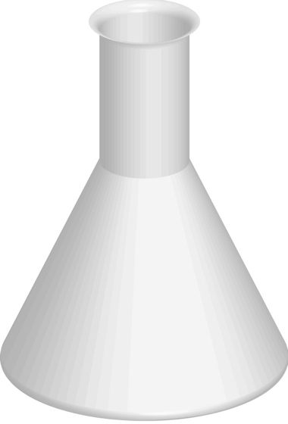 | D | 1
 | When heating a test tube, it should be:  pointed away from yourself and other students.  held with two fingers.  filled completely with the liquid being heated.  heated over a tripod and gauze mat. | A | 1
 | Which of the following is most important in the laboratory?  - Follow a teacher’s instructions.  - Don’t look directly into a test tube.  - Don’t put matches in the sink.  - Wait until equipment is cool before putting it away. | A | 1
 | Match the name of the equipment to its diagram by drawing a line to connect the two |  | 4
  Tripod and gauze mat | 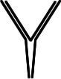
  Conical flask | 
  Filter funnel and filter paper | 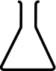
  Test tube | 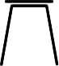
  Beaker
 | A measuring cylinder is a piece of equipment for:  stirring mixtures.  heating substances.  measuring volumes of liquids.  mixing and heating substances. | C | 1
 | What is the name of the process used by cooks to separate large grains from small flour particles?  - Filtration  - Sedimentation  - Sieving  - Gravity separation | C | 1
 | Which mixture could be separated using magnetic attraction?  - Nails and paperclips  - Iron filings and sulfur  - Iron filings and paperclips  - Sand and sulfur | B | 1
 | A solid which dissolves in another  substance is called a:  - solvent.  - solution.  - solute.  - sediment. | C | 1
 | Which one of the following is incorrect? An insoluble substance may:  - form a solution.  - form a suspension.  - form a sediment.  - float on top of a liquid. | A | 1
 | Stuart is vacuuming the carpeted areas of his house. The filtrate (the substance that passes through the filter) is the  - carpet.  - air.  - vacuum cleaner.  - dust. | B | 1
 | Which of the following is a correct statement about how a filter works?  - Only gases can pass through a filter.  - Solids may be forced through filter paper, leaving a liquid in the folded paper cone.  - Particles which are too big are trapped by the filter.  - A filter will separate all dissolved solids from the liquid. | C | 1
 | Decanting is:  - pouring liquid from a beaker or flask down the sink.  - pouring the entire contents of one beaker into another more conveniently sized beaker.  - tipping a liquid into a filter paper sitting in another beaker.  - tipping the liquid in one beaker into another, leaving some solid in the bottom of the first beaker. | D | 1
 | Inks can be separated into their coloured components by:  - filtration.  - chromatography.  - crystallisation.  - distillation. | B | 1
 | Why is water considered to be an important solvent?  - Water occurs in large quantities on Earth.  - Water dissolves the chemicals needed by both plant and animal cells.  - Water is useful for cleaning clothes and washing kitchen utensils.  - Water is a colourless liquid. | B | 1
 | What is the best way to obtain sugar from a sugar solution?  - Condensation  - Evaporation  - Sieving  - Filtration | B | 1
 | To make a chocolate milkshake more concentrated, should you add more milk or more flavouring? | More flavouring | 1
 | Give two examples of solutions found in  the home. | Answers will vary. Examples include flavoured drinks, cleaning products and medicines. | 2
 | A squeeze of lemon juice is mixed with a glass of cold water to make a homemade lemon drink. Which is the:  - solute?  - solvent?  - solution? | - The lemon juice  - The cold water  - Lemon drink | 3
 | In gold panning, a mixture of gravel and gold particles are swirled around in water, and the gold remains in the pan while the gravel is swirled out into the river with some of the water.  Explain the separation principle used here. | The heavier, denser gold particles remain at the bottom of the pan while the lighter gravel is swirled out with some of the water. The process is repeated with fresh water until all the gravel is swirled out and only grains of heavy gold remain. | 2
 | (a) Name three different methods of separating mixtures.  (b) Select ONE of these and describe in a few sentences how the method works. | Any three of: distillation, decanting, separating funnel, centrifuging, flocculation, chromatography, filtration or crystallisation.  Examples include: separating funnel. Mix some olive oil and water in a beaker and pour into a separating funnel. Allow the two layers to form. Open the tap and allow the lower layer to run out into a clean beaker. Turn the tap off once all of the lower layer is removed. Tip the remainder into a second beaker. | 5
 | Explain the meaning of each of the following terms.  - Solution  - Solvent  - Saturated solution  - Sediment | - The clear mixture formed when one substance is dissolved in another.  - The substance in which another substance dissolves.  - A solution in which no more solute can be dissolved.  - Solid that settles to the bottom of a liquid. | 4
 | How would you best separate the following mixtures?  - Sawdust and water  - Sugar dissolved in water  - The different colours in a brown marker pen  - Peas and water | - Filtration/sieving  - Evaporation/crystallisation  - Chromatography  - Sieving/ decanting | 4
 | A student uses a chemical that has the warning label shown below.  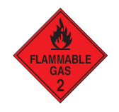  A chemical has this sign on its bottle. What does this sign tell you about the chemical?  A It reacts explosively with water.  B It can be absorbed by the skin.  C It is easily set on fire.  D It can be used to extinguish fires. | C | 1

